

MINI PROJECT REPORT

Project Phase – 1 REPORT
Submitted by
Sharad Patel [202407020188]
Avinash Patel [202407020028]
Tilak Patel [202407020219]
Jeet Patel [202407020087]
in partial fulfilment for the award of the degree of
BACHELOR OF TECHNOLOGY
COMPUTER SCIENCE ENGINEERING
Project Mentor
Ms. Pragya Vats
UNITEDWORLD INSTITUTE OF TECHNOLOGY
KARNAVATI UNIVERSITY
Uvarsad, Gandhinagar, Gujarat – 382422

July – November, 2026

Table of Contents

1. Abstract
Modern enterprise and campus computer networks support critical services requiring near-continuous availability and deterministic performance. Conventional network management depends predominantly on reactive fault detection—relying on Simple Network Management Protocol (SNMP) polling thresholds, syslog alerts, and manual troubleshooting. Consequently, engineers typically identify bottlenecks, link saturations, and node failures only after service degradation or complete downtime has already affected end users.
This project, NetGuard AI: AI-Based Network Fault Prediction, addresses these limitations by establishing a proactive, machine learning-driven network monitoring and fault prediction framework. The system continuously evaluates 8 core network telemetry parameters: Latency (ms), Packet Loss (%), Bandwidth Utilization (%), Throughput (Mbps), CPU Utilization (%), Memory Utilization (%), Network Traffic (Mbps), and Error Rate (%).
Using a supervised machine learning approach, the project evaluates Decision Tree, Logistic Regression, and Random Forest classifiers to predict network operational states categorized into three distinct severity levels: Normal, Warning, and Critical. Trained and validated on a structured dataset of 6,000 multi-node telemetry records, the optimized Random Forest Classifier achieved an overall test classification accuracy of 97.93% (Precision: 0.9804, Recall: 0.9793, F1-Score: 0.9794).
The complete solution is deployed as an interactive, multi-view administrative dashboard built using Streamlit, Plotly, and Scikit-Learn. The application provides dynamic telemetry visualization, simulated live monitoring, an interactive "Simulation Lab" for stress-testing network thresholds, automated risk-level alerts, and CSV batch validation.

2. Introduction

2.1 Problem Statement
Traditional computer network monitoring architectures operate reactively:
- Unexpected Downtime: Failures in core routing or switching elements propagate across subnets before network administrators can intervene.
- Complex Multi-Parameter Correlation: Network anomalies rarely originate from a single parameter. High latency accompanied by normal CPU usage may signify upstream link congestion, whereas high latency paired with elevated CPU and error rates often indicates switch backplane starvation or hardware degradation. Human operators cannot continuously correlate these multi-dimensional telemetry streams in real time.
- Threshold Rigidities: Static threshold monitoring (e.g., alert if CPU > 85%) produces high false-positive rates during benign traffic spikes and fails to detect composite anomalies where several parameters degrade moderately beneath their individual thresholds.
- Manual Diagnostic Overhead: Isolating degraded links or rogue broadcast domains requires manual CLI diagnostics (e.g., traceroute, show interfaces, ping sweeps), prolonging Mean Time to Repair (MTTR).
Predictive network monitoring applies machine learning classifiers across continuous telemetry features to detect subtle pre-failure signatures, enabling remediation before complete packet drop or outage occurs.

2.2 Aim and Objectives
The primary aim of this project is to develop an AI-based system that analyzes multi-variate network performance data to classify and predict network operational faults prior to system degradation.
Core Objectives:
- Collect and monitor 8 critical telemetry parameters: Latency, Packet Loss, Bandwidth Utilization, Throughput, CPU Utilization, Memory Utilization, Network Traffic, and Error Rate.
- Establish a structured, rule-based severity scoring model to serve as the ground truth for classifying network health into Normal, Warning, and Critical states.
- Train, optimize, and cross-evaluate multiple supervised machine learning models (Decision Tree, Logistic Regression, and Random Forest).
- Identify feature importance rankings to determine the dominant telemetry indicators driving network failures.
- Implement an interactive diagnostic dashboard featuring live monitoring simulations, parameter sensitivity stress-testing, automated alert generation, and CSV dataset ingestion.
- Validate the operational boundaries and document the precise technical scope of the model.

2.3 Scope of the Project
- Scope Covered: Multi-variable anomaly classification, historical offline batch analysis via CSV ingestion, interactive parameter stress-testing, multi-class risk scoring, and interactive web dashboard visualization.
- Target Deployment Environments: Campus local area networks (LANs), academic computer labs, enterprise edge distribution blocks, and virtualized private cloud network gateways.
- Operational Scope and Limitations:
  - The machine learning model is trained on a synthetic dataset of 6,000 records structured around deterministic boundary conditions; it does not connect via live SSH/SNMP sockets to physical network appliances.
  - Fault indicators represent algorithmic predictions based on telemetry anomalies rather than direct hardware-level failure confirmations.
  - Automated alerts are rendered directly within the dashboard UI; third-party push notification channels (SMS/SMTP/Webhooks) are reserved for future work.

3. System Requirements and Design

3.1 Hardware Requirements
Component | Minimum Specification | Recommended Specification
Processor | Intel Core i3 / AMD Ryzen 3 (Dual-Core, 2.0 GHz) | Intel Core i5 / AMD Ryzen 5 or higher (Quad-Core, 2.5+ GHz)
RAM | 4 GB DDR4 | 8 GB or 16 GB DDR4/DDR5
Storage | 10 GB available SSD/HDD storage | 20 GB available NVMe M.2 SSD storage
Network Interface | Standard 10/100 Mbps Ethernet / 802.11n Wi-Fi | Gigabit Ethernet (1000 Mbps) / 802.11ac/ax Wi-Fi
Display | 1366 × 768 standard resolution | 1920 × 1080 Full HD or higher

3.2 Software Requirements
Category | Specification / Tool | Purpose in Project
Operating System | Windows 10/11 (64-bit), Ubuntu 20.04+, or macOS | Development and deployment host
Programming Language | Python 3.10 – 3.12 | Primary backend scripting and ML implementation
Development IDE | Visual Studio Code / Jupyter Notebook | Source code editing, debugging, and terminal execution
Data Manipulation | Pandas (>= 2.0.0), NumPy (>= 1.24.0) | Matrix manipulation, dataset generation, vector operations
Machine Learning | Scikit-Learn (>= 1.3.0) | Model training, classification, pipeline execution, metrics
Model Persistence | Joblib (>= 1.3.0) | Serializing and loading the trained classifier .pkl file
User Interface | Streamlit (>= 1.50.0) | Interactive reactive web dashboard
Data Visualization | Plotly (>= 5.18.0) | Multi-series time-series charts, radar charts, gauge meters
Network Modeling | Cisco Packet Tracer v8.x | Topology architectural design and simulation layout

3.3 System Architecture
The NetGuard AI platform is structured into four primary functional layers:
- Telemetry Ingestion Layer: Ingests simulated telemetry feeds or user-uploaded CSV files containing the 8 key metrics.
- Preprocessing & Validation Layer: Enforces column presence checks, casts values to 64-bit floating-point numbers, validates metric domains against baseline ranges, and applies Scikit-Learn standardization scalers where appropriate.
- Machine Learning Inference Engine: Loads the serialized fault_prediction_model.pkl pipeline. It generates class probability distributions across Normal, Warning, and Critical labels, and calculates a normalized 0–100 Risk Score.
- Presentation & Alert Layer: Built on Streamlit, this layer presents time-series telemetry trends, radar charts of parameter excursions, classification matrices, and visual status alerts.
+-----------------------------------------------------------------------+
| 1. TELEMETRY INGESTION |
| - Simulated Telemetry Generator (Demo Mode) |
| - Offline CSV Dataset Upload (network_dataset.csv) |
+-----------------------------------------------------------------------+
|
v
+-----------------------------------------------------------------------+
| 2. PREPROCESSING & VALIDATION |
| - Schema and Missing Value Validation |
| - Feature Extraction (8 Core Telemetry Metrics) |
| - Normalization & Boundary Verification |
+-----------------------------------------------------------------------+
|
v
+-----------------------------------------------------------------------+
| 3. MACHINE LEARNING INFERENCE ENGINE |
| - Serialized Random Forest Classifier (fault_prediction_model.pkl) |
| - Decision Tree & Logistic Regression Benchmark Pipelines |
| - Dynamic Risk Score Calculation (0 - 100 Scale) |
+-----------------------------------------------------------------------+
|
v
+-----------------------------------------------------------------------+
| 4. PRESENTATION & ALERT LAYER |
| - Executive KPI Dashboard & Real-Time Status Banners |
| - Multi-Device Time-Series Telemetry & Anomaly Radar Plots |
| - Interactive Simulation Lab (Slider-Driven Prediction) |
| - In-App Alert Notifications (Normal / Warning / Critical) |
+-----------------------------------------------------------------------+

3.4 Diagrams

3.4.1 Cisco Packet Tracer Network Topology
The enterprise network architecture modeled for this project represents a hierarchical campus network topology comprising Core, Distribution, and Access layers.
 +----------------------+
| 2911 Edge Router |
| (Router0) |
+----------+-----------+
|
|
+----------+-----------+
| Cisco 2960-24TT |
| Core Switch |
+----+-----+-----+-----+
| | |
+----------------+ | +----------------+
| | |
v v v
+------------------+ +------------------+ +------------------+
| Server-PT | | Server-PT | | Server-PT |
| Network Data Svr | | AI Prediction Svr| | Monitoring Svr |
+------------------+ +------------------+ +------------------+
| |
v v
+------------------+ +------------------+
| Cisco 2960-24TT | | Cisco 2960-24TT |
| Access Switch 1 | | Access Switch 2 |
+----+-----+---+---+ +----+-----+---+---+
| | | | | |
PC0 PC1 PC2 PC3 PC4 |
v
+------------------+
| AccessPoint-PT |
+--------+---------+
|
+------+------+
| |
Laptop0 Tablet0
- 
Core Switch (Cisco 2960-24TT Core Switch): Central aggregation point linking the edge router to dedicated servers and floor distribution switches.
- Network Data Server: Aggregates and logs network flow records and telemetry metrics.
- AI Prediction Server: Hosts the Python/Streamlit inference service executing the trained Random Forest classifier.
- Monitoring Server: Provides administrative dashboard access and displays real-time health metrics.
- Access Switches & Wireless AP: Distribute network connectivity across end-user workstations (PC0–PC4) and mobile endpoints (Laptop0, Tablet0).

3.4.2 System Data Flow Diagram (DFD Level-1)
[ Network Telemetry Source ]
(Simulated Stream / CSV)
|
| (Raw Telemetry: Latency, Loss, CPU, etc.)
v
+--------------------------+
| 1.0 Data Ingestion & | <--- Telemetry Validation Rules
| Schema Validation |
+-------------+------------+
|
| (Sanitized Feature Matrix: 8 Attributes)
v
+--------------------------+
| 2.0 Feature Normalization|
| & Vector Formatting |
+-------------+------------+
|
| (Normalized Feature Vector X)
v
+--------------------------+
| 3.0 Machine Learning | <--- Loaded Model Parameters
| Inference Engine | (fault_prediction_model.pkl)
+-------------+------------+
|
+-----------------------+
| |
(Class Probabilities) (Predicted State)
| |
v v
+--------------------------+ +--------------------------+
| 4.0 Risk Score | | 5.0 Alert Generation & |
| Computation Engine | | Visualization UI |
+-------------+------------+ +--------------+-----------+
| |
+--------------+---------------+
|
v
[ Administrative User ]
(Dashboard Gauges & Alerts)

3.4.3 End-to-End AI Prediction & Alert Pipeline
[ Incoming Telemetry Tuple ]
|
+---> [ Latency > 250ms? ]
+---> [ Packet Loss > 5%? ]
+---> [ Bandwidth > 90%? ]
+---> [ CPU > 90%? ]
+---> [ Memory > 90%? ]
+---> [ Throughput < 100 Mbps? ]
+---> [ Error Rate > 5%? ]
+---> [ Traffic > 900 Mbps? ]
|
v
[ Scikit-Learn Pipeline ] ---> [ Random Forest Ensemble (100 Trees) ]
|
+------------------+------------------+
| | |
v v v
P(Normal) P(Warning) P(Critical)
\ | /
\ | /
v v v
[ Final ArgMax Prediction Classification ]
|
+---------------------+---------------------+
| | |
v v v
Status: OK Status: WARNING Status: CRITICAL
Risk: 0 - 30 Risk: 31 - 70 Risk: 71 - 100
(Green Indicator) (Amber Indicator) (Red Alert Pop)

4. Implementation

4.1 Technologies Used
The system is implemented in Python using the following specialized packages:
- Scikit-Learn (v1.3+): Used to construct data pipelines, train estimators, and compute cross-validated classification metrics.
- Pandas & NumPy: Used to manipulate structured dataframes, compute statistical summaries, and vectorize mathematical operations.
- Random Forest Classifier (sklearn.ensemble.RandomForestClassifier): Selected as the primary model. Random Forests aggregate predictions across 100 decorrelated decision trees, mitigating overfitting on noisy edge telemetry while naturally modeling non-linear, multi-variable interactions.
- Decision Tree & Logistic Regression: Trained alongside the Random Forest to establish baseline comparisons.
- Joblib: Provides high-throughput serialization and deserialization of the trained model dictionary, metadata, and evaluation results.
- Streamlit & Plotly: Used to construct a reactive administrative UI with interactive gauges, scatter matrices, and dynamic telemetry charts.

4.2 Machine Learning Pipeline and Evaluation

4.2.1 Dataset Description
The dataset (network_dataset.csv) contains 6,000 multi-node telemetry records. It includes 8 feature attributes:
- latency: Continuous float, range [1, 500] ms.
- packet_loss: Continuous float, range [0, 100] %.
- bandwidth_utilization: Continuous float, range [0, 100] %.
- throughput: Continuous float, range [0, 1000] Mbps.
- cpu_utilization: Continuous float, range [0, 100] %.
- memory_utilization: Continuous float, range [0, 100] %.
- network_traffic: Continuous float, range [0, 1000] Mbps.
- error_rate: Continuous float, range [0, 10] %.
The target variable is fault_label, categorized into Normal, Warning, and Critical.

4.2.2 Experimental Model Evaluation and Comparison
The dataset was split using an 80/20 train-test partition (4,500 training samples, 1,500 test samples, fixed random seed 42).
Comparative Performance Across Evaluated Models:
Model Algorithm | Accuracy | Precision (Weighted) | Recall (Weighted) | F1-Score (Weighted)
Decision Tree | 97.13% | 0.9723 | 0.9713 | 0.9715
Logistic Regression | 97.53% | 0.9764 | 0.9753 | 0.9754
Random Forest (Selected) | 97.93% | 0.9804 | 0.9793 | 0.9794

4.2.3 Class-Wise Evaluation Metrics (Random Forest)
Class Label | Precision | Recall | F1-Score | Test Support
Normal | 0.9957 | 0.9928 | 0.9942 | 693 samples
Warning | 0.9361 | 0.9927 | 0.9636 | 413 samples
Critical | 1.0000 | 0.9416 | 0.9699 | 394 samples

4.2.4 Confusion Matrix
The test confusion matrix for the Random Forest model (1,500 samples) is structured as follows:
 Predicted: Normal Predicted: Warning Predicted: Critical
Actual: Normal 688 5 0
Actual: Warning 3 410 0
Actual: Critical 0 23 371
- 
True Normal Identifications: 688 of 693 normal traffic instances were correctly classified.
- Zero False Alarms for Critical: 0 normal traffic patterns were incorrectly classified as Critical faults.
- Zero Critical Misses into Normal: 0 Critical failures were classified as Normal, preventing catastrophic unflagged outages.

4.2.5 Telemetry Feature Importance
Telemetry Feature | Relative Importance Weight | Architectural Significance
Bandwidth Utilization | 23.17% | Strongest indicator of impending buffer bloat and queue exhaustion.
CPU Utilization | 22.98% | Indicates packet processing bottlenecks and routing engine saturation.
Memory Utilization | 13.97% | Captures state table overflows (NAT, ARP, routing tables).
Latency | 13.95% | Primary symptom of end-to-end transmission degradation.
Packet Loss | 10.10% | Direct indicator of tail-drops and physical layer link integrity issues.
Throughput | 6.59% | Reflects available capacity and transport-layer throttling.
Error Rate | 5.18% | Captures CRC errors and duplex mismatch conditions.
Network Traffic | 4.06% | Baseline traffic volume metric.

4.3 Screenshots and Outputs
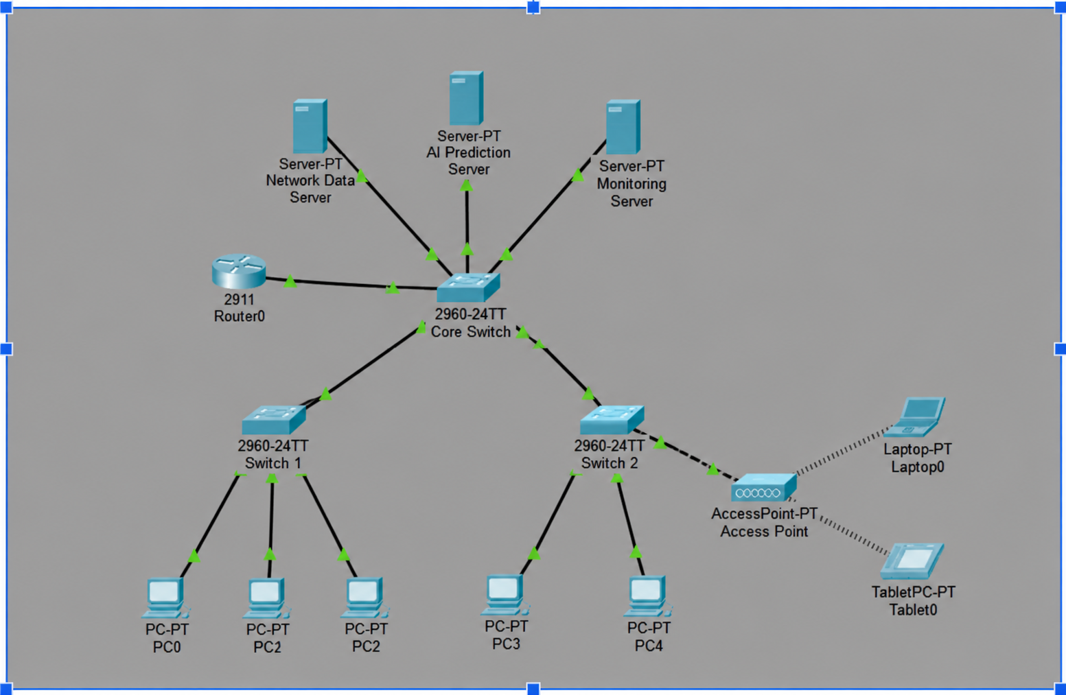

5. Conclusion
Phase 1 of the AI-Based Network Fault Prediction project demonstrates the viability and performance of supervised machine learning for proactive network fault classification. By moving beyond traditional single-variable reactive threshold alerts, the system correlates 8 fundamental network telemetry metrics simultaneously.
Experimental results across 6,000 dataset records confirm that the Random Forest Classifier outperforms Decision Tree and Logistic Regression models, achieving a peak accuracy of 97.93% and an F1-score of 0.9794. Feature importance analysis demonstrates that Bandwidth Utilization (23.17%) and CPU Utilization (22.98%) serve as the most critical predictors of impending network instability.
The accompanying Streamlit dashboard provides network administrators with real-time risk scoring, visual multi-metric telemetry tracking, and an interactive simulation environment for operational planning.

6. Future Scope
To extend the system toward enterprise deployment, future development phases will target:
- Live SNMP and Telemetry Streaming: Integrating live SNMP v2c/v3 polling and streaming telemetry collectors (e.g., gNMI, Telegraf) to ingest metrics directly from physical Cisco Catalyst switches and edge routers.
- Deep Learning for Sequence Modeling: Evaluating Long Short-Term Memory (LSTM) networks and Temporal Convolutional Networks (TCN) to capture temporal dependencies and predict failures hours in advance.
- Automated Notification Gateways: Integrating webhook-based notifications to dispatch automated alerts through enterprise channels (Slack, Microsoft Teams, PagerDuty, SMS).
- Automated Remediation (Self-Healing Networks): Coupling the predictive model with Software-Defined Networking (SDN) controllers to automatically throttle abusive flows, re-route traffic around degraded links, or adjust QoS profiles prior to link failure.

